What is the status? The impact of reduced composition data on the ability to monitor rebuilding for overfished fish stocks

Chantell R. Wetzel1,2,

1Northwest Fisheries Science Center, National Marine Fisheries Service, 2725 Montlake Boulevard East, Seattle, WA 98112, United States

2School of Aquatic and Fishery Sciences, University of Washington, Seattle, WA 98195-5020, United States

ABSTRACT

*Keywords*:

Management Strategy Evaluation, simulation, rebuilding, limited data

*Corresponding author*: C.R. Wetzel

*Email:* [Chantell.Wetzel@noaa.gov](mailto:Chantell.Wetzel@noaa.gov)

*Phone*: 1-206-302-1753

*Fax*: 1-206-860-6792

# Introduction

Declaring a stock overfished often results in harvest restrictions due to legally-required rebuilding guidelines. The severity of restrictions on harvest for some stocks can lead to a situation where the ability to collect data becomes limited, so that stocks that may have been data-rich become data-limited over a period (of rebuilding) when managers are likely most concerned about stock status.

Harvests under rebuilding requirements have been dramatic relative to the historical landings for several overfished rockfish species off the U.S. West Coast (e.g. Yelloweye, Widow, Canary, Cowcod). By 2002, the Pacific Fishery Management Council (PFMC) had declared nine stocks overfished, the majority being slow growing long-lived rockfish (XXX). One example is yelloweye rockfish which was declared overfished in 2002, resulting in drastic reductions in harvest limits (Methot and Piner 2002). Similar to other rockfish species on the West Coast, the high catches observed during the 1980s and early 1990s were unsustainable and harvest limit for the first year under the rebuilding plan was less than 10% of the catch four years earlier (Stewart et al. 2009). Yelloweye rockfish present an interesting case study, but not entirely unique among other West Coast rockfish, as they are encountered infrequently by the main fishery-independent survey due to the sampling method (trawl), and the majority of the information, albeit somewhat limited, was coming primarily from fishery samples, both recreational and commercial. During rebuilding, retention has been prohibited in the recreational fishery, and the harvest limits have been low enough to create an avoidance behavior by the commercial fishery (ref). The most recent full assessment cites the limited recent fishery data as a challenge to “produce conclusive information about the stock for the foreseeable future” (Stewart et al. 2009). While yelloweye rockfish may have never been considered traditionally data-rich, since entering rebuilding, the amount of data available for subsequent assessment now more resembles that of a data-limited situation, something that may pose significant challenges for science and management in the future.

Data is necessary to determine the extent to which a stock is on track to rebuild within the legally-mandated timeframe. Although limiting harvest of an overfished stock will naturally allow it to recover, being able to measure the rate of recovery is still crucial to management, and increased uncertainty due to limited data can impede this process. Also, biological data are critical to improve estimates of key parameters within stock assessments (e.g. natural mortality, growth, steepness) and can indicate incoming poor or strong year-classes (recruitment) which can impact estimates of depletion levels (i.e. relative stock biomass). Potential improvements in parameter estimates and the ability to detect potential incoming fluctuations in spawning biomass during rebuilding will be restricted when little new biological data are being collected due to harvest restrictions. There have been numerous simulation studies evaluating the impact of data on the performance of stock assessment methods (e.g. Chen et al. 2003, Yin and Sampson 2004, Magnusson and Hilborn 2007, Wetzel and Punt 2011, Lee et al. 2012). The focus of such studies is often on the ability to estimate either management quantities or biological parameters. However, to date, these studies have not addressed the long-term impact of reduced data have on the ability to monitor a stock during rebuilding.

This paper simulates an overfished flatfish and rockfish stock where harvest and the collection of new data are restricted to address three main questions; 1) does the increased uncertainty due to limited data impact the ability to correctly detect when an overfished stock is rebuilt, 2) is there a degradation of rebuilding performance with limited data and if so how does this change as the amount of data increases, and 3) what is the impact of restricted data based on life-history?

# Materials and Methods

## General approach

Two life-history types that are common to U.S. west coast groundfish were simulated; a fast growing, short-lived flatfish and a slow growing, long-lived rockfish (Table 1). Each simulated population was modeled using an age-structured model. An annual index of abundance was observed with error and composition data were collected for selected years, and used by an estimation method to estimate population size and a corresponding catch level. The catches were then applied to the simulated stock. The data generation, catch estimation and stock updating was conducted in an iterative fashion for 50 or 100 years for the flatfish and rockfish life-histories respectively.

## The operating model

The numbers-at-age at the start of the year are computed using the equation:

 (1)

where  is the number of fish of age *a* at the start of the year *t*,  is the number of age-0 animals at the start of year *t*,  is the selectivity by gender and age, *A* is the plus group,  is the instantaneous fishing mortality rate during year *t*, and *M* is the instantaneous rate of natural mortality (assumed to be independent of age, gender and time). The number of age-0 fish is related to spawning biomass according to the Beverton-Holt stock recruitment relationship:

 (2)

where  is the spawning biomass at the start of the spawning season in year *t*,  is the standard deviation of recruitment in log space, and *h* is the recruitment compensation (also known as steepness).

A non-equilibrium starting condition was created by applying equations (1) and (2) for the number of years equal to the maximum age for each life-history prior to the start of fishing with variation in recruitment and *F*=0. The initial period of the fishery operated for 50 years, with the catch of fish of age *a* during year *t* in numbers determined by:

 (3)

Historical (years 1-39) fishing mortality was selected so that the populations were in an overfished state, based upon the corresponding life-history PFMC relative biomass target levels. The depletion level at the start of year 50 for rockfish was 0.15 and flatfish was 0.08.

The population was assessed at the start of year 50. An annual survey index of abundance with high uncertainty (CV = 0.50), fishery and survey composition data were available to the assessment. The majority of the composition data, lengths and ages, were collected from the fishery with only limited samples from the survey. Depending upon the data scenario (See Data Scenarios), the quantity of composition data from the fishery was dramatically reduced if the stock was correctly estimated to be overfished. The data reduction from the fishery continued until the stock was estimated to be rebuilt to the target biomass level, after which sampling intensity returned to the pre-assessment level.

The depletion and the resulting catches were estimated by the estimation method. The catches were removed from the population exactly, and an index of abundance along with composition data were generated for the subsequent four years. This iterative process was repeated over a period of time (flatfish; 50 years, rockfish; 100 years), at which time the performance of the estimation methods were summarized using the performance measures. The estimation method was applied to 100 simulated populations for each data scenario.

## The estimation method

Stock synthesis (SS), an integrated statistical catch-at-age model, was used for assessment of the simulated population. Growth and the steepness of the Beverton-Holt stock recruit relationship were assumed known without error. *R0*, natural mortality, recruitment deviations, initial age-structure deviations, and specific selectivity parameters were estimated. The variance-covariance matrix was estimated for the first three assessments (years: 50, 54, and 58) to calculate the asymptotic standard errors of the estimated recruitment deviations and hence the appropriate annual recruitment bias adjustment (Methot and Taylor 2011):

 (4)

where  is the asymptotic standard error of the estimated recruitment deviation for year *t*. Initial analyses showed that the level of bias correction estimated did not significantly vary beyond the third assessment. The estimated bias adjustment estimated by the third assessment (year 58) was applied to all subsequent assessments with only the ending years being extended accordingly.

The catches were estimated by the assessment and adjusted by the PFMC harvest control rule (rockfish; 40-10 or flatfish; 25-5), that reduced the catch linearly when the stock was below the target biomass level (see Punt et al. 2008 for details). The catches were then reduced again by the PFMC uncertainty buffer for a category 1 stock (see Ralston et al. 2011 for details).

## Data scenarios

Three data scenarios were created to explore the impact of the amount and precision of data on the ability to monitor rebuilding of an overfished stock. The same historical data were available to each of the data scenarios for years 31-49 with an annual survey index of abundance with high uncertainty (CV = 0.50), fishery lengths (n = 100 yr-1) and ages (n = 50 yr-1), and survey lengths (n = 5 yr-1) and ages (n = 5 yr-1). The data available was designed to emulate a stock that was infrequently encountered by the survey (e.g. due to depth or habitat) and the majority of the data available were from the fishery. Following the first assessment in year 51 the data scenarios diverge based on composition data availability. The “no reduction” data scenario continued with the same data quantity (i.e. annual survey, annual composition data) for either 50 or 100 years depending upon life-history. The second data scenario, “reduced data”, substantially reduced the composition data available from the fishery during the period the stock was assessed overfished where annual length and age sample sizes from the fishery were reduced to 25 yr-1 and 12 yr-1 respectively, but retained an annual index of abundance and the same level of sampling from the survey (length and ages, n = 5 yr-1). The sample sizes remained at low levels until the stock was assessed to be rebuilt, at which time the sample sizes returned to the historical level from the fishery (length n = 100 yr-1; ages n = 50 yr-1). The “reduced data” scenario was designed to be representative of the potential data reduction that can occur in overfished stocks when management either greatly limits the landings or retention of a stock. The final data scenario, “eliminated data”, removed all composition data with only an annual index of abundance following the assessment in year 51. The “eliminated data” scenario was implemented to provide insight into how long it takes for assessment performance to degrade in the absence of composition data.

## Data generation

The observation model was used to generate an index of abundance. The expected biomass available for observation during each year *t* is:

 (5)

where  is the age-length-based transition matrix (see Methot and Wetzel [2013] for details),  is the average weight for fish in length-class *l*, and  is the selectivity by the survey for length-class *l*. The observed survey biomass is generated using:

 (6)

where *Q*is the catchability coefficient for the survey, and $σ_{s}$ is the standard deviation of the survey catchability in log space (see Table ).

The observed length and age composition data for the fishery and survey catch was assumed to be multinomially distributed. The proportions of the catch by length *l* during year *t* for the fishery or survey *f* were calculated as:

 (7)

where  is the catch in year *t* by fishery or survey *f* for age *a* and length-class *l*, and *x* is a small constant (1.0 E-5) added to each bin. The age composition data were generated in a similar fashion as the length data but were summed over lengths.

## Performance measures

One hundred simulations were conducted for each data scenario and life-history, with the difference among replicates due to annual recruitment variation and observation error. The relative errors (REs) were calculated for the estimated selectivity and natural mortality parameters, as well as the estimated depletion and spawning biomass. The REs were calculated as:

 (8)

where ** is the *i*th estimated quantity of interest and  is the *i*th true value from the operating model. The root mean square error (RMSE), a measure of precision and bias, was also calculated for the assessment year depletion and *SB*0 to assess the overall level of error given the amount of data available:

 (9)

The year the stock was assessed to be recovered to the depletion target was recorded and compared to when the population in the operating model stock actually recovered. The difference between the estimated and actual recovery year was divided by the mean generation time (Table 1) for the corresponding life-history to have comparable scales between the life-histories. The mean generation times were based on virgin conditions.

# Results

The estimation failed to correctly estimate the stock overfished neither by the first assessment nor the subsequent assessments for a small number of simulation for each life-history. The flatfish and rockfish life-histories resulted in 12 and 6 runs, respectively, in which the estimation method failed to determine that the stock was below the overfished threshold in any years (i.e. depletion < 0.125 and 0.25 respectively) t. Examining these runs showed that the estimation method estimated a positively biased depletion (e.g. a higher relative biomass level relative to the true state) which was above the overfished declaration threshold in the first assessment. Although the stock status was estimated greater than the true, the estimated catches with the reductions applied by the PFMC harvest control rule and buffer allowed the stock to grow to a state such that either one of two situations occurred; 1) by the subsequent assessment the stock was no longer overfished, or 2) the stock was still overfished although closer to the overfished threshold and the estimate from depletion was positively biased once again. The reductions in data for the “reduced data” scenario only occurred when the estimation method determined that the stock was overfished. Hence, these select simulations for the “reduced data” scenario retained the full sample sizes for the entire period. For this reason, these simulations were removed from all scenarios. Upon exploration the removal of the specific runs did not impact the results.

The median estimates of spawning biomass and stock depletion were similar for the “reduced data” and “no reduction” scenarios relative to the medians of the true population for both the flatfish and rockfish life-histories in their respective performance (Fig 1 and 2). Each data scenario resulted in median estimates that were either marginally above (rockfish) or below (flatfish) the median of the true population trajectories in the final assessment years. This pattern of behavior was slightly worse in the “reduced data” scenario, only improving for the flatfish life-history in latter assessments when the stock was estimated rebuilt and sample sizes increased again. While the estimates from the “eliminated data” scenario were similar for the flatfish life-history (Fig 1e and 2e), the rockfish life-history estimated a lower median spawning biomass and a more depleted population relative to the true median depletion of the stock (Fig 1f and 2f). The “eliminated data” scenario for rockfish resulted in positively biased virgin spawning biomass estimates which led to the negative bias in estimated depletion (Table 2). The 95% simulation intervals from the median estimates of spawning biomass and depletion for both life-histories were strikingly smaller for the “eliminated data” scenario compared to the other two scenarios that had some form of data during the rebuilding period (Fig 1e-f and 2e-f). This was also reflected in smaller RMSE values for the flatfish life-history (Table 3). The rockfish final depletion RMSEs for the “eliminated data” scenario are not significantly different from the other data scenarios, because while the estimates became more precise the bias of those estimates also increased.

The flatfish REs for natural mortality improved, reducing bias, during the rebuilding period for both the “no reduction” and “reduced data” scenarios (Fig 3a, c). Flatfish were often estimated rebuilt by the estimation method quickly (e.g. 4-12 years) after which the data levels returned to higher levels allowing for improved estimation performance for natural mortality similar estimates for the “no reduction” scenario. However, the rockfish REs for natural mortality for both of these data scenarios were relatively unbiased over the entire time period (Fig 3b, d). The REs for the “eliminated data” scenario for natural mortality became positively biased relative to the true values and the other data scenarios approximately 20 years after the removal of all composition data for both life-histories (Fig 3e-f).

The estimation method tended to estimate the flatfish stock recovered earlier than the true year of recovery (Fig 4a, c, e). Each of the data-scenarios resulted in a high number of the stocks being declared rebuilt 0.10 – 0.50 mean generation years earlier that the true year of recovery (e.g. 4 – 12). The distribution of rockfish estimated recovery years for each of the data scenarios resulted in more estimated recoveries later than the true recovery year (Fig 4b, d, f), with more of simulations being declared recovered later than true year for the “reduced data” scenario relative to the “no reduction” scenario (Fig 4d). The tail of the distribution favoring later recovery years was most distinct for the “eliminated data” scenario where recoveries ranged from 0.10 – 1.80 mean generations (e.g. 4-82 years) after the true recovery (Fig 4f).

# Discussion

The reduction of data during rebuilding period had limited impact on the estimates of depletion and natural mortality for both life-histories. The presence of historical composition data combined with the uncertain survey index was informative about the natural mortality value and the stock status. Consistent with other studies, adequate composition data were informative about natural mortality (Catalano and Allen 2010, Lee et al. 2011) and the information in the historical composition data maintained estimates of natural mortality even when data levels were reduced. In contrast, the “eliminated data” scenario highlighted that the absence of continuing composition samples will degrade estimates of stock status and natural mortality, even when historical composition data are present (e.g. all data collected prior to the first assessment).

A general trend that was present for both life-histories that was accentuated by the reduction or elimination of data was the incorrect determination of when the stock was recovered to the target depletion value. Final depletion estimates were positively biased for the flatfish life-history leading to estimates of the stock recovering earlier than the true recovery year. However, the estimates about final depletion for the rockfish life-history were negatively biased resulting in the stock being assessed overfished when the true state was recovered. Correctly determining when an overfished stock is rebuilt is a critical goal for fisheries management. Failing to estimate the recovery of a stock result in additional years of increased management restrictions where none are warranted.

The generally good results from each of the data scenarios for both life-histories were related to some key assumptions and choices. Strategic decisions were made to construct a relatively well-behaved operating model population with the estimation method assuming the proper form for critical biological and fishery properties (e.g. known growth, stock-recruitment relationship, and asymptotic selectivity) in order to focus on role of data in the ability to monitor a rebuilding stock. The composition data from a survey and fishery with asymptotic selectivity typically are more informative for the estimation of natural mortality and other biological parameters. If dome-shaped selectivity had been assumed these quantities may have been more difficult to estimate (Bence et al. 2003, Lee et al. 2011, Taylor and Methot 2012).

An additional advantage that each of the data scenarios had was the presence of composition data during the fishing down period and a biomass index that covered both the decline and recovery, despite being highly uncertain. Magnusson and Hilborn (2007) found an improvement of estimates when an index of abundance spanned both the decline and rebuilding of a population, with estimates of reference points and abundance becoming highly uncertain if that information only covered the rebuilding time period.

The composition data were important for model performance as observed in the “eliminated data” scenario where assessment performance declined over time where the only continuing data source was the highly uncertain survey index. Yin and Sampson (2004) determined that the easiest way to improve assessment performance was to increase age composition sampling, rather than increasing survey sampling to reduce the survey CV. The comparison between the scenarios with some composition data, even with small samples sizes, and the “eliminated data” scenario highlight how critical composition data are for model performance when the biomass survey is highly uncertain.

The biology and population dynamics of the real marine system are highly complex and modeling these systems requires simplifying assumptions. Additional modeling should be conducted that assumes an increase in the complexity about the underlying dynamics for true population (e.g. time-varying parameters, environmental driven recruitment) to examine the impact of simplifying assumptions and misspecification in the estimation method on the ability to estimate key management quantities and biological parameters during rebuilding when data sources are limited.

# Acknowledgements

# References

Bence, J.R., Gordoa, A., Hightower, J.E. 1993.Influence of age-selectivity surveys in the reliability of stock synthesis assessments. Can. J. Fish. Aquat. Sci. 50, 827-840.

Catalano, M.J., Allen, M.S 2010. A size-and age-structured model to estimated fish recruitment growth, mortality, and gear selectivity. Fish. Res. 105, 38-45.

Chen, Y., Chen, L., Stergiou, K.I. 2003. Impacts of data quantity on fisheries stock assessment. Aquat. Sci. 65, 92-98.

Lee, H.H., Maunder, M.N., Piner, K.R., Methot, R.D., 2011. Estimating natural mortality within a fisheries stock assessment model: An evaluation using simulation analysis based on twelve stock assessments. Fish. Res. 109, 89-94.

Lee, H.H., Maunder, M.N., Piner, K.R., Methot, R.D., 2012. Can steepness of the stock-recruitment relationship be estimated in fishery stock assessment models? Fish. Res. 125-126, 254-261.

Magnusson, A., Hilborn, R. 2007. What makes fisheries data informative? Fish Fish. 8, 337-358.

Methot, R.D., Piner, K., 2002. Rebuilding analysis for yelloweye rockfish: Update to incorporate results of coastwide assessment in 2002. Pacific Fishery Management Council, 7700 Ambassador Place NE, Suite 200, Portland, OR 97220.12 pp.

Methot, R.D., Taylor, I.G., 2011. Adjusting for bias due to variability of estimated recruitments in fishery assessment models. Can. J. Fish. Aquat. Sci. 68, 1744-1760.

Methot, R.D., Wetzel, C.R., 2013. Stock Synthesis: A biological and statistical framework for fish stock assessment and fishery management. Fish. Res. 142, 86-99.

Punt, A.E., Cope, J.M., Haltuch, M.A. 2008. Reference points and decision rules in U.S. federal fisheries: West Coast groundfish experiences. In: J.L. Nielsen, J.J. Doson, K. Friedland, T.R. Hammon, J. Musick and E. Verspoor [Eds.] Reconciling Fisheries with Conservation: Proceedings of the Fourth World Fisheries Congress. American Fisheries Society Symposium 49. p 1343-1356.

Ralston, S., Punt, A.E., Hamel, O.S., DeVore, J.D., Conser, R.J. 2011. A meta-analytic approach to quantifying scientific uncertainty in stock assessments. Fish. Bull. 109, 217-231.

Stewart, I.J., Wallace, J.R., McGilliard, C., 2009. Status of the U.S. yelloweye rockfish resource in 2009. Pacific Fishery Management Council, 7700 Ambassador Place NE, Suite 200, Portland, OR 97220. 435 pp.

Taylor, I.G., Methot, R.D. Jr. 2012. Hiding or dead? A computationally efficient model of selective fishing mortality. Fish. Res. 142, 75-85.

Wetzel, C.R., Punt. A.E. 2011. Performance of a fisheries catch-at-age model (Stock Synthesis) in data-limited situations. Mar. Fresh. Res. 62, 927-936.

Yin, Y., Samson, D.B. 2004. Bias and precision of estimates from an age-structured stock assessment program in relation to stock and data characteristics. N.A. Jour. Fish. Manag. 24, 865-879.

# Tables

Table 1. Life-history parameters used in the operating model for the flatfish and rockfish life-history.

|  |  |  |
| --- | --- | --- |
| Parameter | Rockfish Life-History  Values | Flatfish Life-History  Values |
| Natural mortality(*M*) | *M* = 0.08 (yr-1) | *M* = 0.15 (yr-1) |
| Steepness(*h*) | *h =* 0.60 | *h =* 0.875 |
| Fishing rate at *BMSY* (*FMSY*) | *FMSY* = 0.05 yr-1 | *FMSY* = 0.20 yr-1 |
| Mean length at *a3* (*L1,γ*)& | *L1,γ*  = 18.00 | *L1,γ* = 24.62 |
| Mean length at *a4* (*L2,γ*) | *L2,γ* = 64.00 (cm) | *L2,γ* = 55.41 (cm) |
| Growth coefficient (*K γ*) | *K γ* = 0.050 (yr-1) | *K γ* = 0.144 (yr-1) |
| Coefficient of variation of length-at-age(*σ0 γa*) | *CV* = 0.08 | *CV* = 0.08 |
| Body weight(*wl,γ*) | *Ω1* = 1.50x10-5 | *Ω1* = 3.42x10-6 |
| Length in cm (*Ll)* | *Ω2* = 3.00 | *Ω2* = 3.346 |
| Maturity slope (*Ω3*) | *Ω3* = -0.500 (yr-1) | *Ω3* = -0.734 (yr-1) |
| Length at 50% maturity (*Ω4*) | *Ω4* = 37.00 (cm) | *Ω4* = 33.10 (cm) |
| Mean Generation Time | *mg =* 26.5 yrs | *mg =* 47.0 yrs |
| Fishery Selectivity& | Double Normal | Double Normal |
| Survey Selectivity& | Double Normal | Double Normal |
| Recruitment variation ($σ_{R}$) | $σ_{R}$ = 0.60 | |
| Catchability Coefficient (*Q)* | *Q* = 1 | |
| Survey Standard Error () | = 0.50 | |

& See Methot and Wetzel (2013) for the parameterization of selectivity and growth.

Table 3. Median REs for virgin spawning biomass (*SB*0) and assessment year depletion for each data scenario and life-history; flatfish (a) and rockfish (b).

|  |  |  |  |  |  |  |  |  |  |
| --- | --- | --- | --- | --- | --- | --- | --- | --- | --- |
|  |  |  | Assessment Year | | | | | | |
| a) Flatfish | | | 54 | 58 | 62 | 66 | 78 | 90 | 98 |
| Median Relative Error | SB0 | No Reduction | -0.04 | -0.04 | -0.05 | -0.04 | -0.02 | 0.01 | 0.00 |
| Reduced Data | -0.04 | -0.04 | -0.04 | -0.04 | -0.02 | 0.00 | 0.01 |
| Eliminated Data | -0.04 | -0.04 | -0.04 | -0.03 | 0.00 | 0.01 | 0.02 |
|  |  |  |  |  |  |  |  |  |
| Final Depletion | No Reduction | 0.15 | 0.14 | 0.15 | 0.09 | 0.04 | 0.02 | -0.01 |
| Reduced Data | 0.15 | 0.17 | 0.11 | 0.10 | 0.04 | 0.03 | -0.01 |
| Eliminated Data | 0.11 | 0.14 | 0.11 | 0.02 | -0.02 | 0.00 | -0.07 |
|  |  |  |  |  |  |  |  |  |  |
|  |  |  | Assessment Year | | | | | | |
| b) Rockfish | | | 58 | 70 | 86 | 102 | 118 | 134 | 150 |
| Median Relative Error | SB0 | No Reduction | 0.00 | 0.00 | 0.00 | 0.01 | 0.02 | 0.02 | 0.01 |
| Reduced Data | 0.00 | 0.00 | 0.00 | 0.01 | 0.01 | 0.01 | 0.02 |
| Eliminated Data | 0.00 | 0.00 | 0.00 | 0.04 | 0.06 | 0.07 | 0.09 |
|  |  |  |  |  |  |  |  |  |
| Final Depletion | No Reduction | -0.08 | -0.08 | -0.09 | -0.08 | -0.05 | -0.08 | -0.07 |
| Reduced Data | -0.08 | -0.09 | -0.12 | -0.12 | -0.06 | -0.08 | -0.07 |
| Eliminated Data | -0.08 | -0.09 | -0.10 | -0.15 | -0.17 | -0.19 | -0.18 |

Table 2. RMSEs for virgin spawning biomass (*SB*0) and assessment year depletion for each data scenario and life-history; flatfish (a) and rockfish (b).

|  |  |  |  |  |  |  |  |  |  |
| --- | --- | --- | --- | --- | --- | --- | --- | --- | --- |
|  |  |  | Assessment Year | | | | | | |
| a) Flatfish | | | 54 | 58 | 62 | 66 | 78 | 90 | 98 |
| RMSE (%) | SB0 | No Reduction | 12 | 14 | 14 | 16 | 16 | 19 | 14 |
| Reduced Data | 13 | 15 | 14 | 16 | 16 | 16 | 15 |
| Eliminated Data | 13 | 13 | 13 | 12 | 13 | 12 | 12 |
|  |  |  |  |  |  |  |  |  |
| Final Depletion | No Reduction | 55 | 113 | 138 | 247 | 338 | 378 | 306 |
| Reduced Data | 77 | 135 | 172 | 200 | 226 | 270 | 224 |
| Eliminated Data | 73 | 61 | 99 | 63 | 47 | 35 | 36 |
|  |  |  |  |  |  |  |  |  |  |
|  |  |  | Assessment Year | | | | | | |
| b) Rockfish | | | 58 | 70 | 86 | 102 | 118 | 134 | 150 |
| RMSE (%) | SB0 | No Reduction | 7 | 8 | 8 | 8 | 6 | 7 | 7 |
| Reduced Data | 8 | 8 | 8 | 8 | 7 | 7 | 7 |
| Eliminated Data | 8 | 8 | 9 | 10 | 10 | 10 | 11 |
|  |  |  |  |  |  |  |  |  |
| Final Depletion | No Reduction | 19 | 20 | 17 | 17 | 18 | 19 | 19 |
| Reduced Data | 20 | 20 | 18 | 18 | 19 | 18 | 20 |
| Eliminated Data | 20 | 21 | 19 | 21 | 32 | 26 | 25 |

# Figures

Figure 1. The median spawning biomass population trajectory from the operating model (white line) with the 95% confidence interval (dashed grey lines) and the estimated median spawning biomass with the 95% confidence intervals from four assessments during the projection period for each data-scenario (a & b: no reduction, c & d: reduced data, and e & f: eliminated data) each life-history (flatfish: a, c, d, and rockfish: b, d, e). Assessments from years 50 (red dashed line),, 54 (blue dashed line), 58 98 (orange dotted line), and 70 (green dot dashed line) are shown for the flatfish life history and years 50 (red dashed line), 78 (blue dashed line), 98 (orange dotted line), 126 (green dot dashed line) for the rockfish life-history..

Figure 2. The median depletion trajectory from the operating model (white line) with the 95% confidence interval (dashed grey lines) and the median estimated depletion and 95% confidence intervals from four assessments during the projection period for each data-scenario (a & b: no reduction, c & d: reduced data, and e & f: eliminated data) each life-history (flatfish: a, c, d, and rockfish: b, d, e). Assessments from years 50 (red dashed line),, 54 (blue dashed line), 58 98 (orange dotted line), and 70 (green dot dashed line) are shown for the flatfish life history and years 50 (red dashed line), 78 (blue dashed line), 98 (orange dotted line), 126 (green dot dashed line) for the rockfish life-history.. The management target depletion for each life-history (flatfish 0.25, rockfish 0.40) is noted by the horizontal dashed line.

Figure 3. The RE for estimates of natural mortality for each assessment and by data-scenario (a & b: no reduction, c & d: reduced data, and e & f: eliminated data) for each life-history (flatfish: a, c, e, and rockfish: b, d, f).

Figure 4. The distribution of when the stock was estimated rebuilt relative to the true rebuilding year in the operating model population standardized by the mean generation time for each data-scenario (a & b: no reduction, c & d: reduced date, and e & f: eliminated data) and life-history (flatfish: a, c, e, and rockfish: b, d, f)..

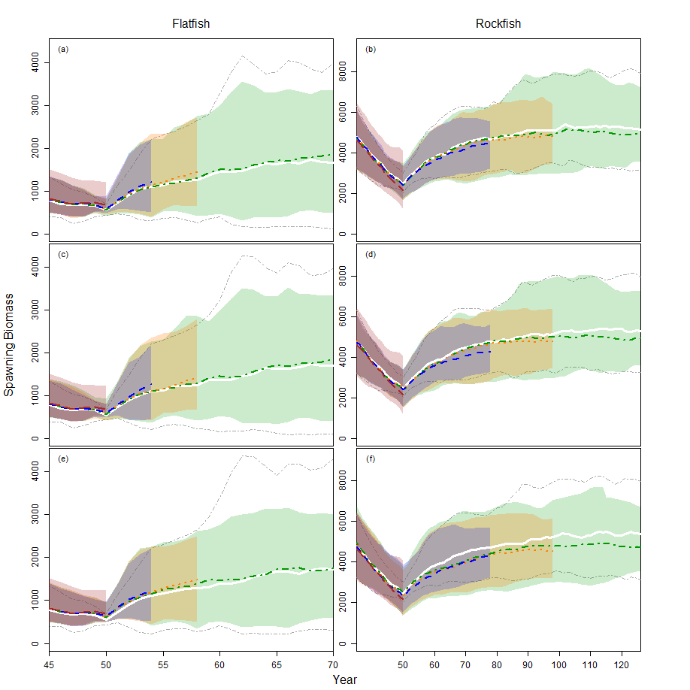

Figure 1

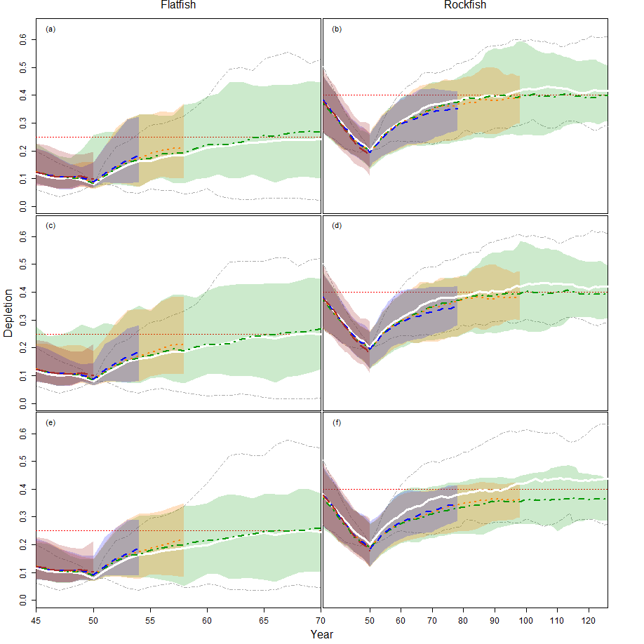

Figure 2

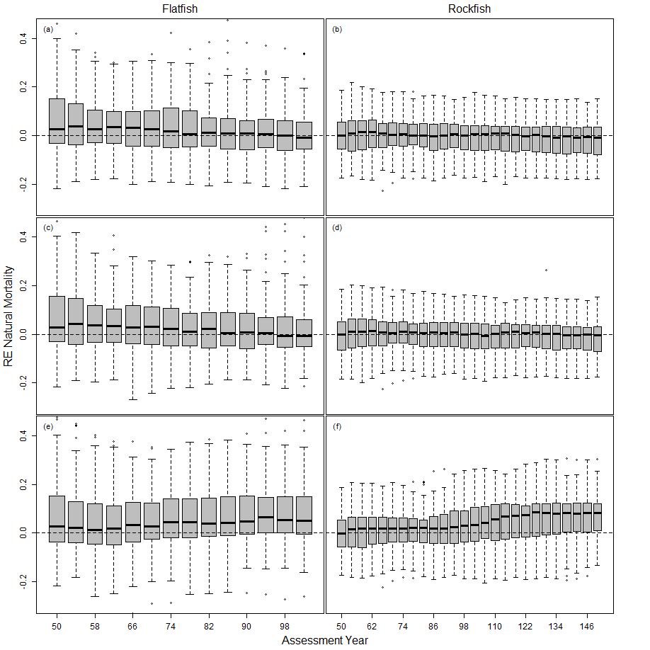

Figure 3

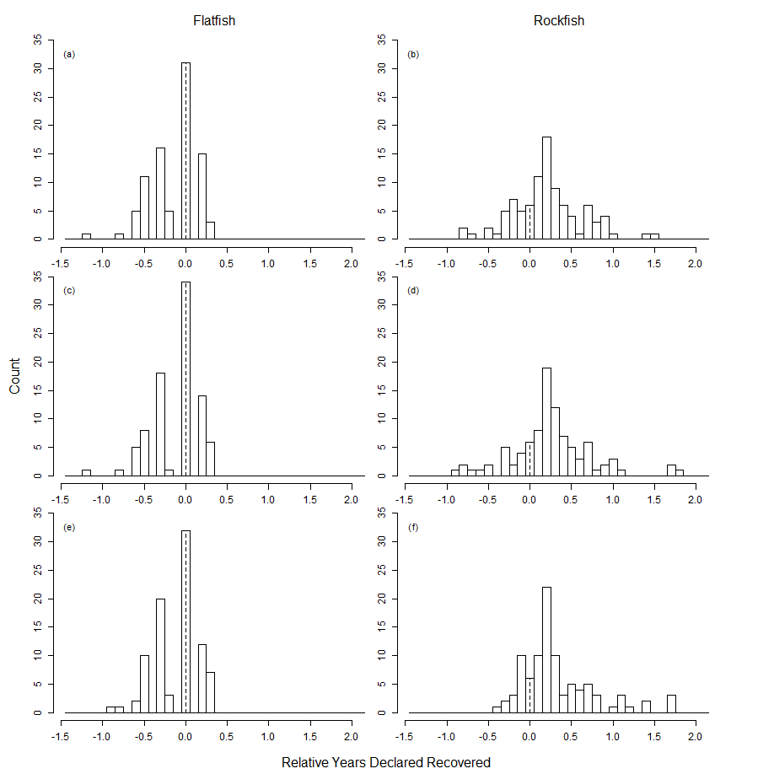

Figure 4